**1.Introduction**

While HTML and CSS handle the structure and presentation of web pages, PHP (Hypertext Preprocessor) adds interactivity and functionality. PHP is a server-side scripting language used to generate dynamic content. It performs tasks like processing forms, managing user authentication, and interacting with databases.PHP scripts are executed on the web server before the HTML is sent to the client’s browser. The server-side processing enables PHP to generate dynamic content based on user input or database queries, making web applications more robust and interactive.Syntax and Basic Constructs in PHPPHP uses a PHP-enabled script file (typically with a .php extension) that contains PHP code embedded within HTML. PHP code is enclosed in <?php and ?> tags.

**1.1Objective**

Use HTML when creating static web pages without needing interactivity or dynamic content. Ideal for informational websites, brochures, or landing pages where content rarely changes. When to Incorporate CSS for Styling: Employ CSS when you want to enhance your web pages’ visual design and layout. It is essential for creating responsive designs that adapt to different screen sizes and devices. Use CSS to maintain a consistent brand identity and user experience. Situations Where PHP Adds Interactivity Use PHP when building web applications that require user input processing, authentication, or database interactions. PHP is invaluable for creating content management systems (CMS), e-commerce platforms, forums, and other dynamic web applications. Choose PHP for scenarios where content needs to change based on user interactions or database updates.

**1.2Problem statement**

To Create a responsive website using php, html, css. Include the database and integration, insert map, form in it.

**1.3 Project Scope**

Anyone who aspires to be a Web Designer could join, various short duration courses for Web Designing Training. Learn the course professionally and become a professional Web Designer. The course duration is from 6 months to one year. In this course, you will learn about HTML, PHP, CSS, Dreamweaver, Magneto, Word press, and Photoshop. Once you have completed a master’s in this field. You can begin your career in reputedThe main career areas in this field include: Front end developer Back end developerPrimary roles of a Frontend and Backend Developer Front end developerThe client-side dealing is usually operated by the front end developer with the graphics, web page design which is accessible to the user.Back end developer The back end development which interacts with the server is operated by the back end developer. PHP, ASP.Net, Java, Cold Fusion, and Perl are the types of languages that are specialized by the Back End Web developer.

**2. System Requirement**

### Hardware Requirement:-

* Server: Multi-core processor, 8GB+ RAM, 512 GB storage.
* Client Devices: Desktops/laptops, tablets/mobile devicess.
* Security Equipment: Firewall, antivirus software, .
* Backup and Redundancy: Backup storage, UPS.

### Software Requirements:-

* Operating System: Linux/Windows for servers, multiple platforms for client devices.
* Database Management System: MySQL.
* Web Server: Apache.
* Programming Languages and Frameworks: PHP, Python, HTML5, CSS3, JavaScript.

**3. Requirement Specification**

**Client Side (Frontend):**HTML (Hypertext Markup Language): Used for creating the structure of web pages.

**CSS (Cascading Style Sheets):** Used for styling the HTML elements, making the web pages visually appealing.

**JavaScript (JS):** Used for implementing dynamic behavior on the web pages, such as handling user interactions and form validations.

**PHP (Hypertext Preprocessor):** Used as the server-side scripting language. PHP handles the dynamic generation of web pages, interacts with the database, and processes user input

.

**MySQL:** A relational database management system used for storing and managing the data related to voters, candidates, elections, etc. MySQL is used to store information such as user credentials, candidate details, voting records, etc.

.

**Server:** The server hosts the backend application built using PHP. It processes the requests from clients, executes PHP scripts, interacts with the database, and sends responses back to the clients.

Common server software includes Apache, Nginx, or other web server software that can handle HTTP requests

.

**Database Server:** Hosts the MySQL database where all the data related to the voting system is stored. It handles queries and data manipulation requested by the backend PHP scripts.

MySQL database schema includes tables for storing information such as user accounts, candidate details, voting records, etc.

**Security Layer:** Implement security measures to ensure the integrity and confidentiality of the voting process. This may include encryption of sensitive data (such as user passwords), implementing measures to prevent SQL injection and other forms of attacks, and securing communication between the client and server using HTTPS.

Design the system architecture to be scalable, allowing it to handle a large number of users and votes without compromising performance. This may involve load balancing, caching mechanisms, and optimizing database queries

**4. Architectural Style:**

#### MVC (Model-View-Controller):

The MVC architectural pattern is well-suited for web-based applications like the Online Driving School **Model:** Represents the data structure and business logic of the application, including entities such as members, Voters, Officers, and equipment. It manages the data and interacts with the database.

**View:** Represents the presentation layer, responsible for rendering user interfaces for activities such as member registration, Election scheduling, and Results.

**Controller:** Acts as an intermediary between the model and the view, handling user inputs, processing requests, and updating the model accordingly. It orchestrates the flow of data and controls the application's behavior.

**Design Patterns:**

#### Factory Method Pattern:

The Factory Method pattern is useful for creating instances of objects based on certain conditions or parameters. In the Online Driving School, the Factory Method pattern can be employed to create different types of members based on selected votes.

#### Decorator Pattern:

The Decorator pattern is useful for adding functionality to objects dynamically, without altering their structure. In the Online Driving School, the Decorator pattern can be applied to enhance the Result module.

#### Singleton Pattern:

The Singleton pattern ensures that a class has only one instance and provides a global point of access to that instance. In the Online Driving School, the Singleton pattern can be used to manage database connections or logging functionality. By implementing the database connection manager or logger as a Singleton, the system ensures that there is only one instance throughout the application, optimizing resource usage and ensuring consistency in data access or logging operations

1. **System Architecture**

Following diagram represents architecture:

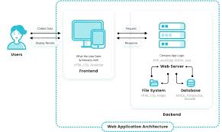

Web architecture refers to the overall structure of a website or web application, including the way it is designed, implemented, and deployed. It involves the use of technologies and protocols such as HTML, CSS, JavaScript, and HTTP to build and deliver web pages and applications to users.Web architecture consists of several components, including the client, the server, the network, and the database. The client is the web browser or application that the user interacts with, and the server is the computer or group of computers that host the website or web application. The network is the infrastructure that connects the the client and the server, such as the internet. Web architecture also includes the design and layout of the website or web application, as well as the way it is organized and the relationships between different pages and components. It also includes the way the website or web application is built and maintained, including the use of frameworks and libraries, and the deployment and hosting of the website .There are several components that make up a web architecture –

The client −This is the web browser or application that the user interacts with. The client sends requests to the server and receives responses from the server.

The server −This is the computer or group of computers that host the website or web application. The server processes requests from the client and sends back the appropriate response.

The network This is the infrastructure that connects the client and the server, such as the internet. It allows for communication between the client and the server.

The database −This is a collection of data that is used to store and retrieve information for the website or web application. The database can be located on the same server as the website or web application, or it can be hosted on a separate server.

The design and layout −This refers to the way the website or web application is structured and organized, including the layout, navigation, and overall appearance.

The frameworks and libraries − These are tools and resources that are used to build and maintain the website or web application. They can include frameworks like Ruby on Rails or Django, or libraries like jQuery or React.

The deployment and hosting − This refers to the way the website or web application is deployed and hosted, including the hosting environment (such as a shared hosting plan or a cloud platform) and the process for deploying updates and change to the website or web application.

1. **Class Diagram**

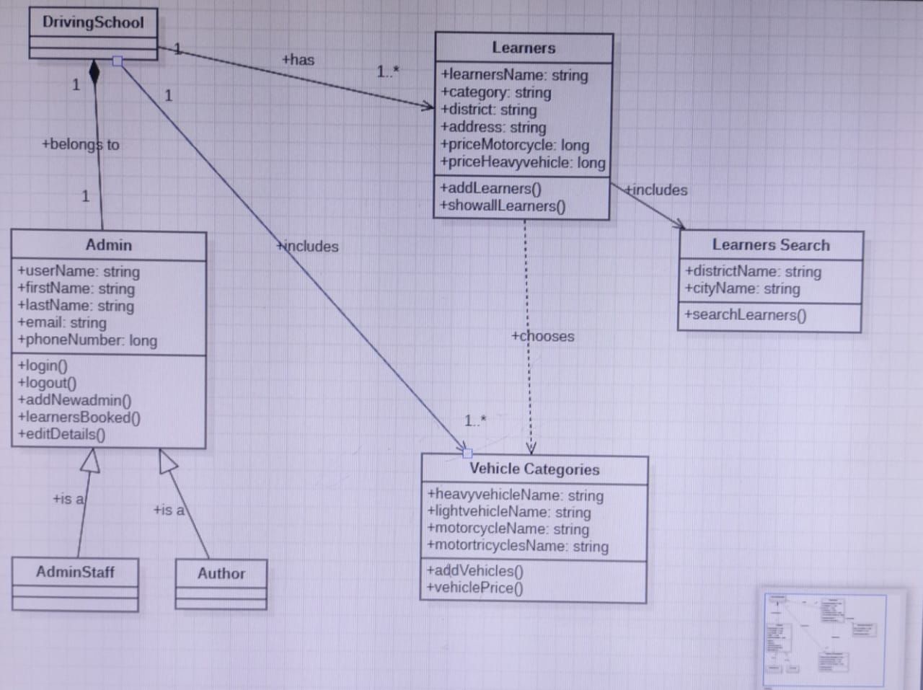

1. **Use Case Diagram**

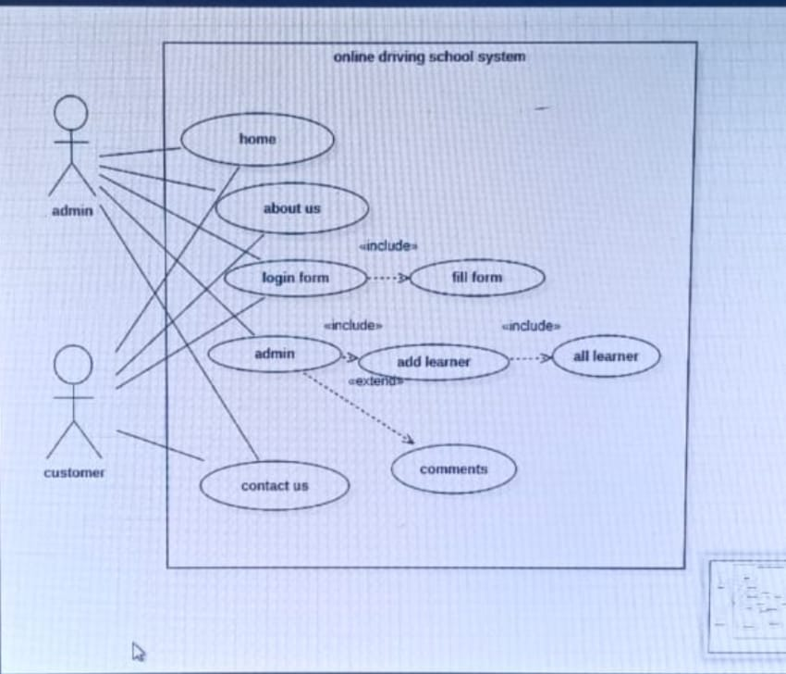

1. **Sequence Diagram**

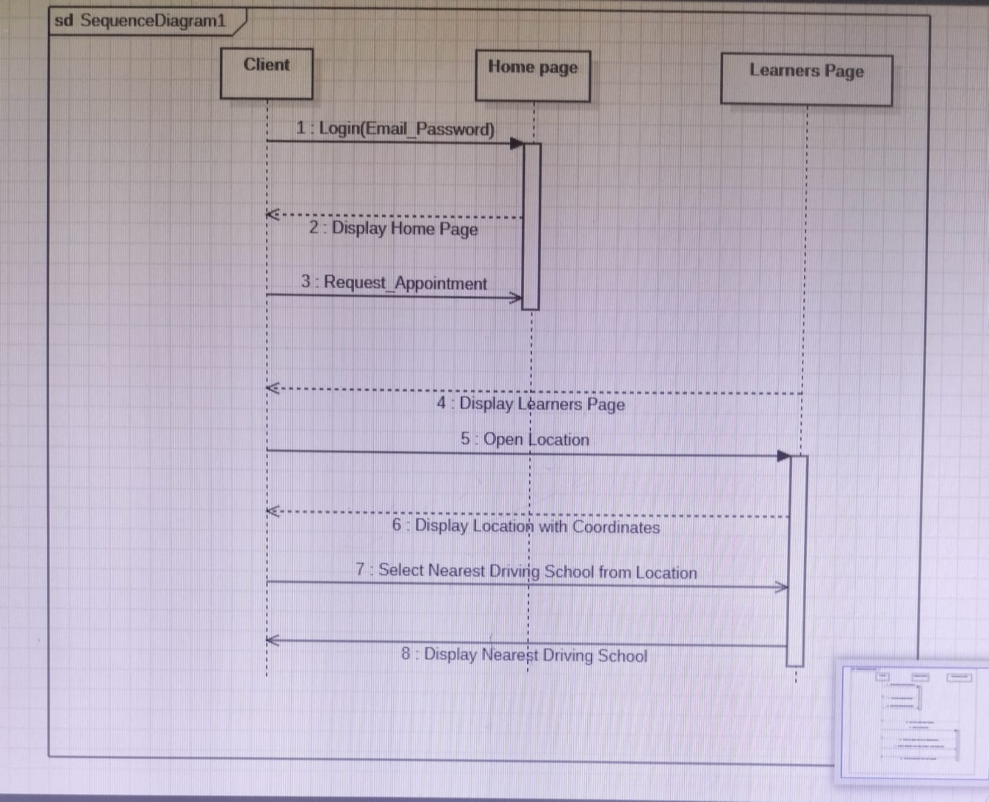

1. **Activity Diagram**

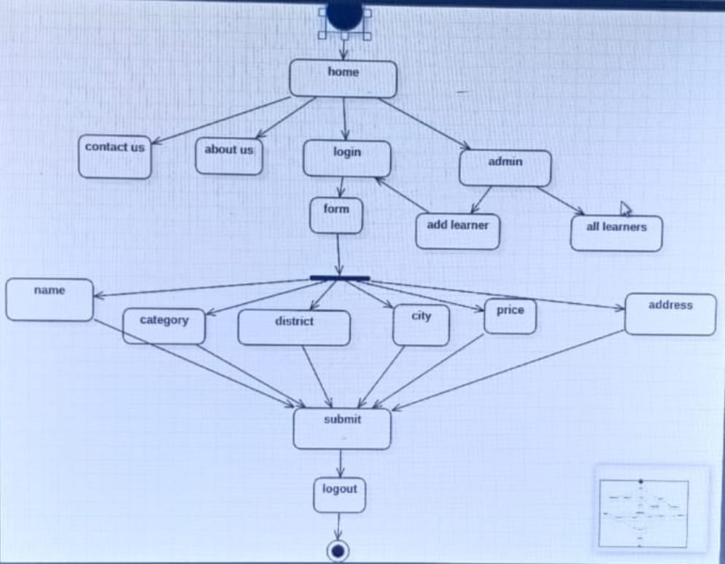

1. **Deployment Diagram**

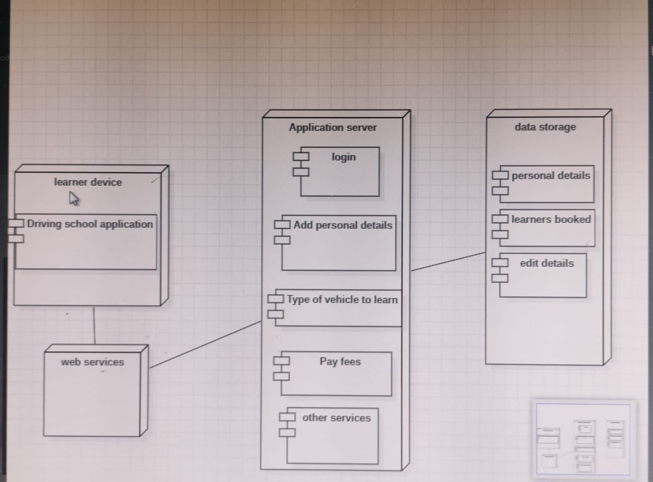

1. **Coding**

<!DOCTYPE html>

<html lang="en">

<head>

<meta charset="utf-8">

<meta content="width=device-width, initial-scale=1.0" name="viewport">

<title>About - Company Bootstrap Template</title>

<meta content="" name="description">

<meta content="" name="keywords">

<!-- Favicons -->

<link href="assets/img/favicon.png" rel="icon">

<link href="assets/img/apple-touch-icon.png" rel="apple-touch-icon">

<!-- Google Fonts -->

<link href="https://fonts.googleapis.com/css?family=Open+Sans:300,300i,400,400i,600,600i,700,700i|Roboto:300,300i,400,400i,500,500i,600,600i,700,700i|Poppins:300,300i,400,400i,500,500i,600,600i,700,700i" rel="stylesheet">

<!-- Vendor CSS Files -->

<link href="assets/vendor/animate.css/animate.min.css" rel="stylesheet">

<link href="assets/vendor/aos/aos.css" rel="stylesheet">

<link href="assets/vendor/bootstrap/css/bootstrap.min.css" rel="stylesheet">

<link href="assets/vendor/bootstrap-icons/bootstrap-icons.css" rel="stylesheet">

<link href="assets/vendor/boxicons/css/boxicons.min.css" rel="stylesheet">

<link href="assets/vendor/glightbox/css/glightbox.min.css" rel="stylesheet">

<link href="assets/vendor/remixicon/remixicon.css" rel="stylesheet">

<link href="assets/vendor/swiper/swiper-bundle.min.css" rel="stylesheet">

<!-- Template Main CSS File -->

<link href="assets/css/style.css" rel="stylesheet">

<!-- =======================================================

* Template Name: Company

* Updated: Jan 29 2024 with Bootstrap v5.3.2

* Template URL: https://bootstrapmade.com/company-free-html-bootstrap-template/

* Author: BootstrapMade.com

* License: https://bootstrapmade.com/license/

======================================================== -->

</head>

<body>

<!-- ======= Header ======= -->

<header id="header" class="fixed-top">

<div class="container d-flex align-items-center">

<h1 class="logo me-auto"><a href="index.html"><span>Com</span>pany</a></h1>

<!-- Uncomment below if you prefer to use an image logo -->

<!-- <a href="index.html" class="logo me-auto me-lg-0"><img src="assets/img/logo.png" alt="" class="img-fluid"></a>-->

<nav id="navbar" class="navbar order-last order-lg-0">

<ul>

<li><a href="index.html">Home</a></li>

<li class="dropdown"><a href="#"><span>About</span> <i class="bi bi-chevron-down"></i></a>

<ul>

<li><a href="about.html" class="active">About Us</a></li>

<li><a href="team.html">Team</a></li>

<li><a href="testimonials.html">Testimonials</a></li>

<li class="dropdown"><a href="#"><span>Deep Drop Down</span> <i class="bi bi-chevron-right"></i></a>

<ul>

<li><a href="#">Deep Drop Down 1</a></li>

<li><a href="#">Deep Drop Down 2</a></li>

<li><a href="#">Deep Drop Down 3</a></li>

<li><a href="#">Deep Drop Down 4</a></li>

<li><a href="#">Deep Drop Down 5</a></li>

</ul>

</li>

</ul>

</li>

<li><a href="services.html">Services</a></li>

<li><a href="portfolio.html">Portfolio</a></li>

<li><a href="pricing.html">Pricing</a></li>

<li><a href="blog.html">Blog</a></li>

<li><a href="contact.html">Contact</a></li>

</ul>

<i class="bi bi-list mobile-nav-toggle"></i>

</nav><!-- .navbar -->

<div class="header-social-links d-flex">

<a href="#" class="twitter"><i class="bu bi-twitter"></i></a>

<a href="#" class="facebook"><i class="bu bi-facebook"></i></a>

<a href="#" class="instagram"><i class="bu bi-instagram"></i></a>

<a href="#" class="linkedin"><i class="bu bi-linkedin"></i></i></a>

</div>

</div>

</header><!-- End Header -->

<main id="main">

<!-- ======= Contact Section ======= -->

<div class="map-section">

<iframe style="border:0; width: 100%; height: 350px;" src="https://www.google.com/maps/embed?pb=!1m14!1m8!1m3!1d12097.433213460943!2d-74.0062269!3d40.7101282!3m2!1i1024!2i768!4f13.1!3m3!1m2!1s0x0%3A0xb89d1fe6bc499443!2sDowntown+Conference+Center!5e0!3m2!1smk!2sbg!4v1539943755621" frameborder="0" allowfullscreen></iframe>

</div>

<section id="contact" class="contact">

<div class="container">

<div class="row justify-content-center" data-aos="fade-up">

<div class="col-lg-10">

<div class="info-wrap">

<div class="row">

<div class="col-lg-4 info">

<i class="bi bi-geo-alt"></i>

<h4>Location:</h4>

<p>A108 Adam Street<br>New York, NY 535022</p>

</div>

<div class="col-lg-4 info mt-4 mt-lg-0">

<i class="bi bi-envelope"></i>

<h4>Email:</h4>

<p>info@example.com<br>contact@example.com</p>

</div>

<div class="col-lg-4 info mt-4 mt-lg-0">

<i class="bi bi-phone"></i>

<h4>Call:</h4>

<p>+1 5589 55488 51<br>+1 5589 22475 14</p>

</div>

</div>

</div>

</div>

</div>

<div class="row mt-5 justify-content-center" data-aos="fade-up">

<div class="col-lg-10">

<form action="forms/contact.php" method="post" role="form" class="php-email-form">

<div class="row">

<div class="col-md-6 form-group">

<input type="text" name="name" class="form-control" id="name" placeholder="Your Name" required>

</div>

<div class="col-md-6 form-group mt-3 mt-md-0">

<input type="email" class="form-control" name="email" id="email" placeholder="Your Email" required>

</div>

</div>

<div class="form-group mt-3">

<input type="text" class="form-control" name="subject" id="subject" placeholder="Subject" required>

</div>

<div class="form-group mt-3">

<textarea class="form-control" name="message" rows="5" placeholder="Message" required></textarea>

</div>

<div class="my-3">

<div class="loading">Loading</div>

<div class="error-message"></div>

<div class="sent-message">Your message has been sent. Thank you!</div>

</div>

<div class="text-center"><button type="submit">Send Message</button></div>

</form>

</div>

</div>

</div>

</section><!-- End Contact Section -->

</main><!-- End #main -->

1. **Result**

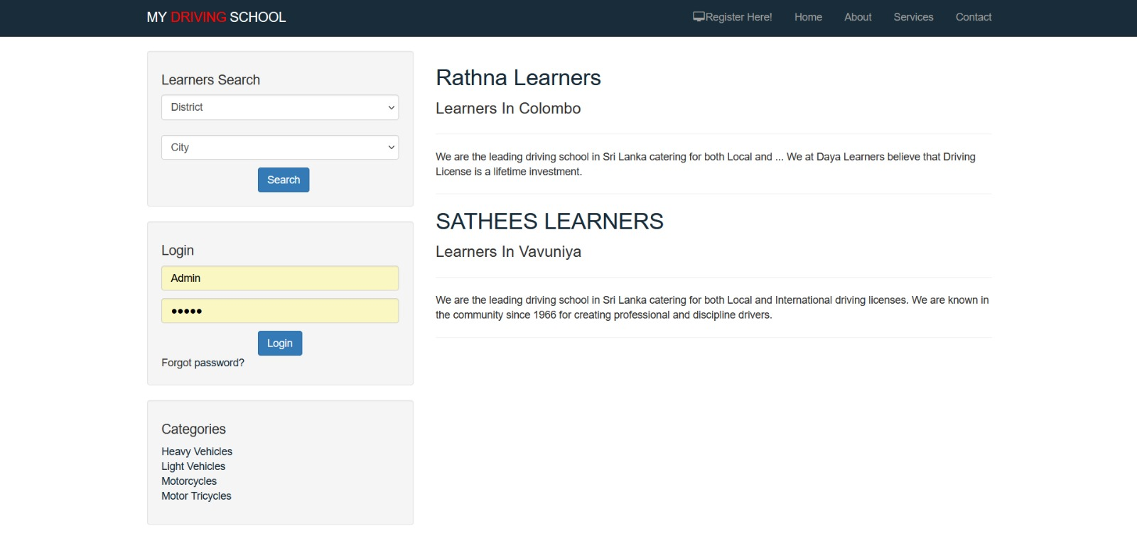

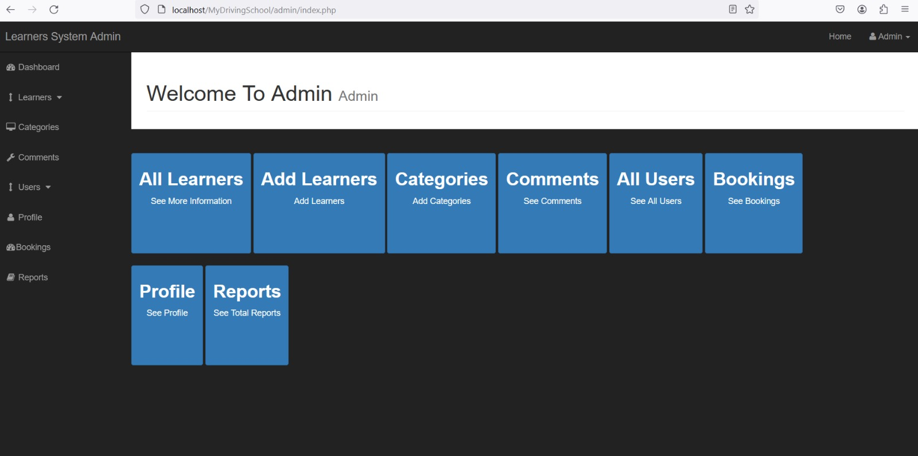

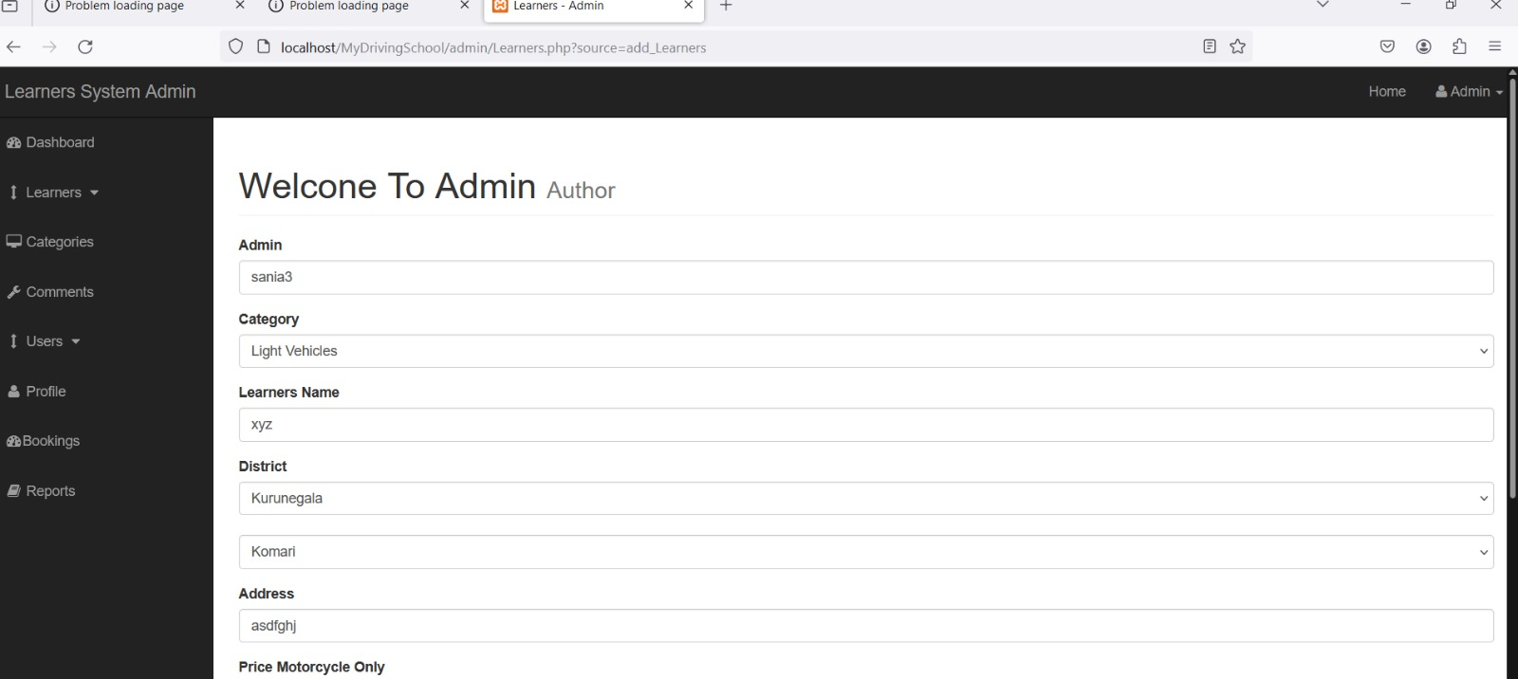

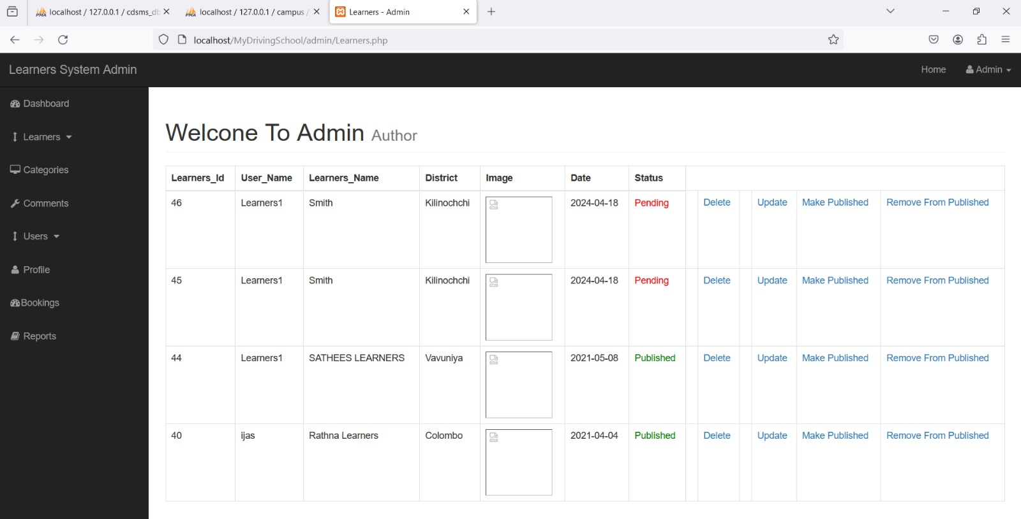

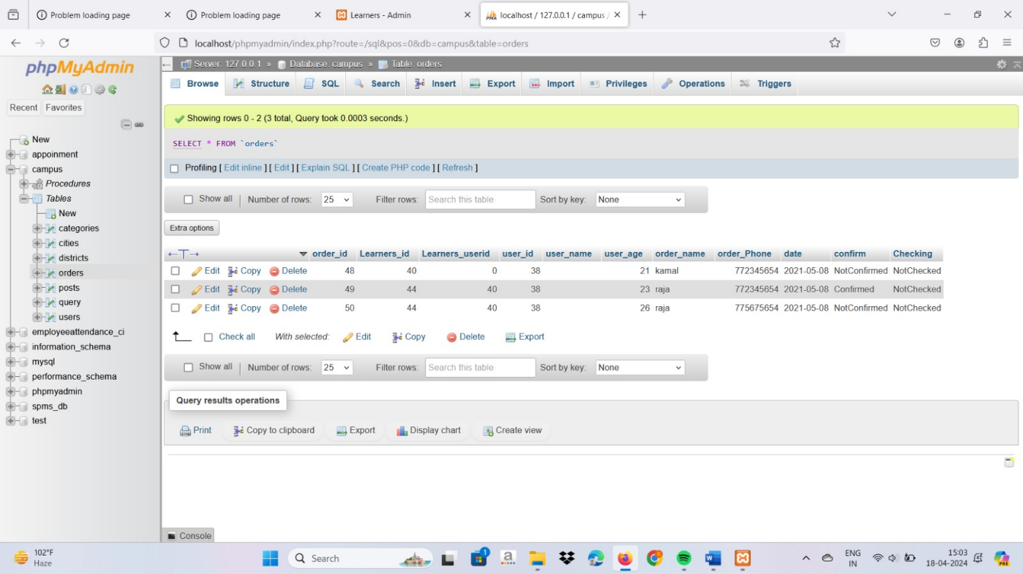

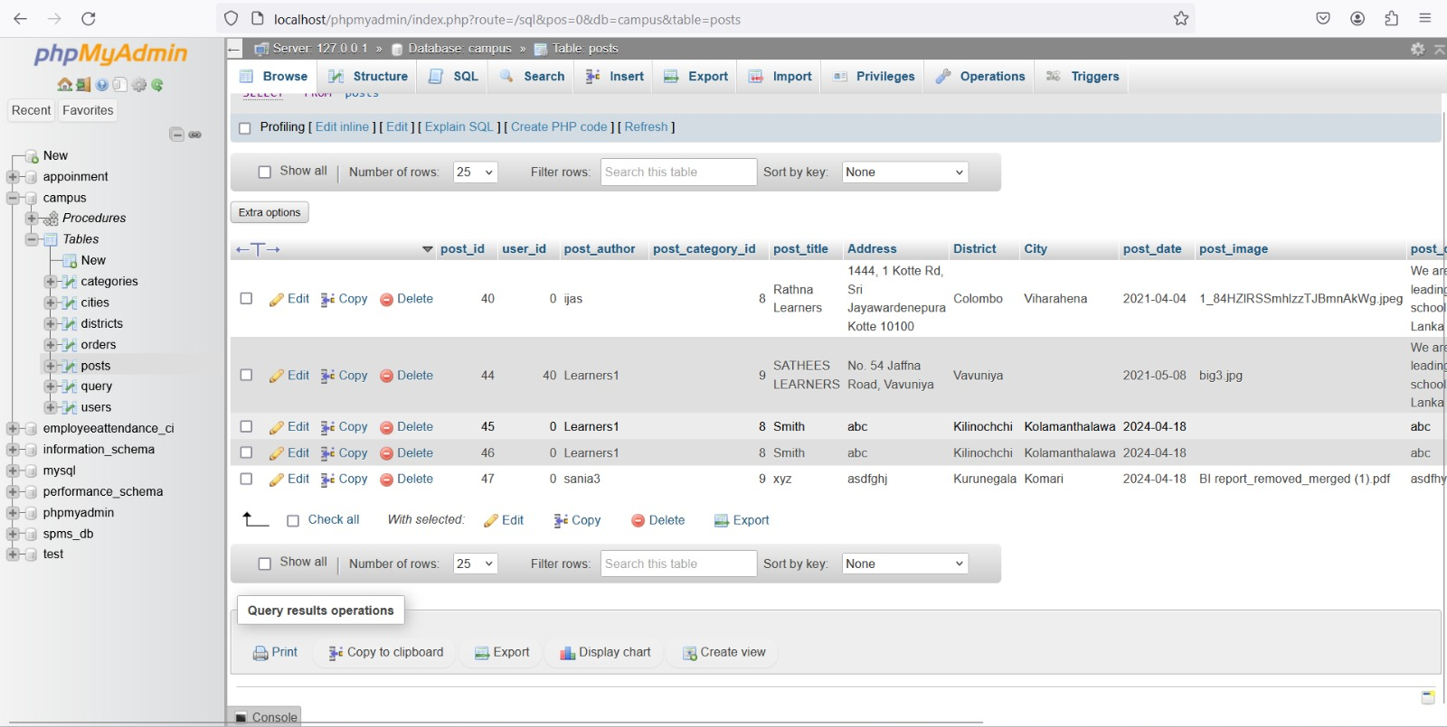

1. **Advantages and Disadvantages**

**13.1 Advantages**

Open-source and Free-to-use. PHP is an open-source language, which means it is free to use by developers.Easy to Learn and Use. PHP has a vast set of tutorials, resources, and other insights that anyone can use to learn this language effortlessly.Platform Independent.

HTML: It establishes the foundation of a web page by organizing and structuring the content. It defines headings, paragraphs, images, links, lists, tables, forms, and other structural elements.

CSS: It enhances the appearance of the web page by applying styles to the HTML elements.

It is platform-independent. PHP-based applications can run on any OS like UNIX, Linux, Windows, etc. Applications can easily be loaded which are based on PHP and connected to the database.

It’s mainly used due to its faster rate of loading over slow internet speed than other programming language.

It has less learning curve because it is simple and straightforward to use. Someone familiar with C programming can easily work on PHP.

It is more stable for a few years with the assistance of providing continuous support to various versions.

It helps in reusing an equivalent code.

**13.2 Disadvantages**

Limited interactivity: While HTML and CSS can create a static web page, they lack the ability to create more advanced interactions that JavaScript can provide. Without JavaScript, it's difficult to create animations, user input validation, and real-time updatet is not that secure due to its open-source, because the ASCII text file is often easily available.

It is not suitable for giant content-based web applications.

It has a weak type, which can cause incorrect data and knowledge to users.

PHP frameworks got to learn to use PHP built-in functionalities to avoid writing additional code.

Using more features of PHP framework and tools cause poor performance of online applications.

PHP doesn’t allow change or modification in the core behavior of online applications.

The PHP frameworks aren’t equivalent in behavior so does their performance and features.

While PHP may be a powerful tool supported by an outsized community and plentiful reference documentation, there are easier programming languages for web apps.

1. **Benefits of the Design Patterns**

### Factory Method Pattern:

The Factory Method pattern facilitates the creation of membership objects based on selected packages.

It enhances flexibility by allowing the system to instantiate different types of memberships without tightly coupling the client code to specific membership classes. This pattern simplifies the addition of new membership packages in the future, as the system can easily accommodate changes without requiring modifications to existing code.

### Observer Pattern:

The Observer pattern enables efficient communication between objects without direct coupling. It enhances scalability by allowing multiple observers (members and trainers) to subscribe to class updates.This pattern promotes modularity, as changes in class schedules can be propagated to all subscribed observers without modifying the classes themselves.

### Decorator Pattern:

The Decorator pattern facilitates the dynamic addition of features to billing and payment processes. It promotes code reusability by allowing the system to add new billing options or promotions without modifying existing billing classes.This pattern enhances maintainability, as changes in billing functionalities can be implemented by adding new decorators instead of modifying the core billing classes.

### Singleton Pattern:

The Singleton pattern ensures that database connections and logging functionality are globally accessible and consistent throughout the application. It optimizes resource usage by maintaining a single instance of critical resources, such as database connections, reducing overhead. This pattern enhances performance and reliability, as it eliminates the overhead of creating multiple instances and ensures consistent behavior across the application.

1. **Conclusion**

We came across the Design Pattern, Architectural styles and UML Diagrams like Class Diagram, Use Case Diagram, Activity Diagram, Sequence Diagram, Deployment Diagram. Thus, we created responsive website using php, html and css. We included form, google maps, and database integration as well.

## References

https:/[/www.w3schools.com/html/default.asp](http://www.w3schools.com/html/default.asp) https://[www.w3schools.com/css/default.asp](http://www.w3schools.com/css/default.asp) https://[www.w3schools.com/js/default.asp](http://www.w3schools.com/js/default.asp) https://[www.w3schools.com/php/default.asp](http://www.w3schools.com/php/default.asp)